A Winters Exhibition

At Great Glemham Village Hall,
Low Road, IP17 2DH

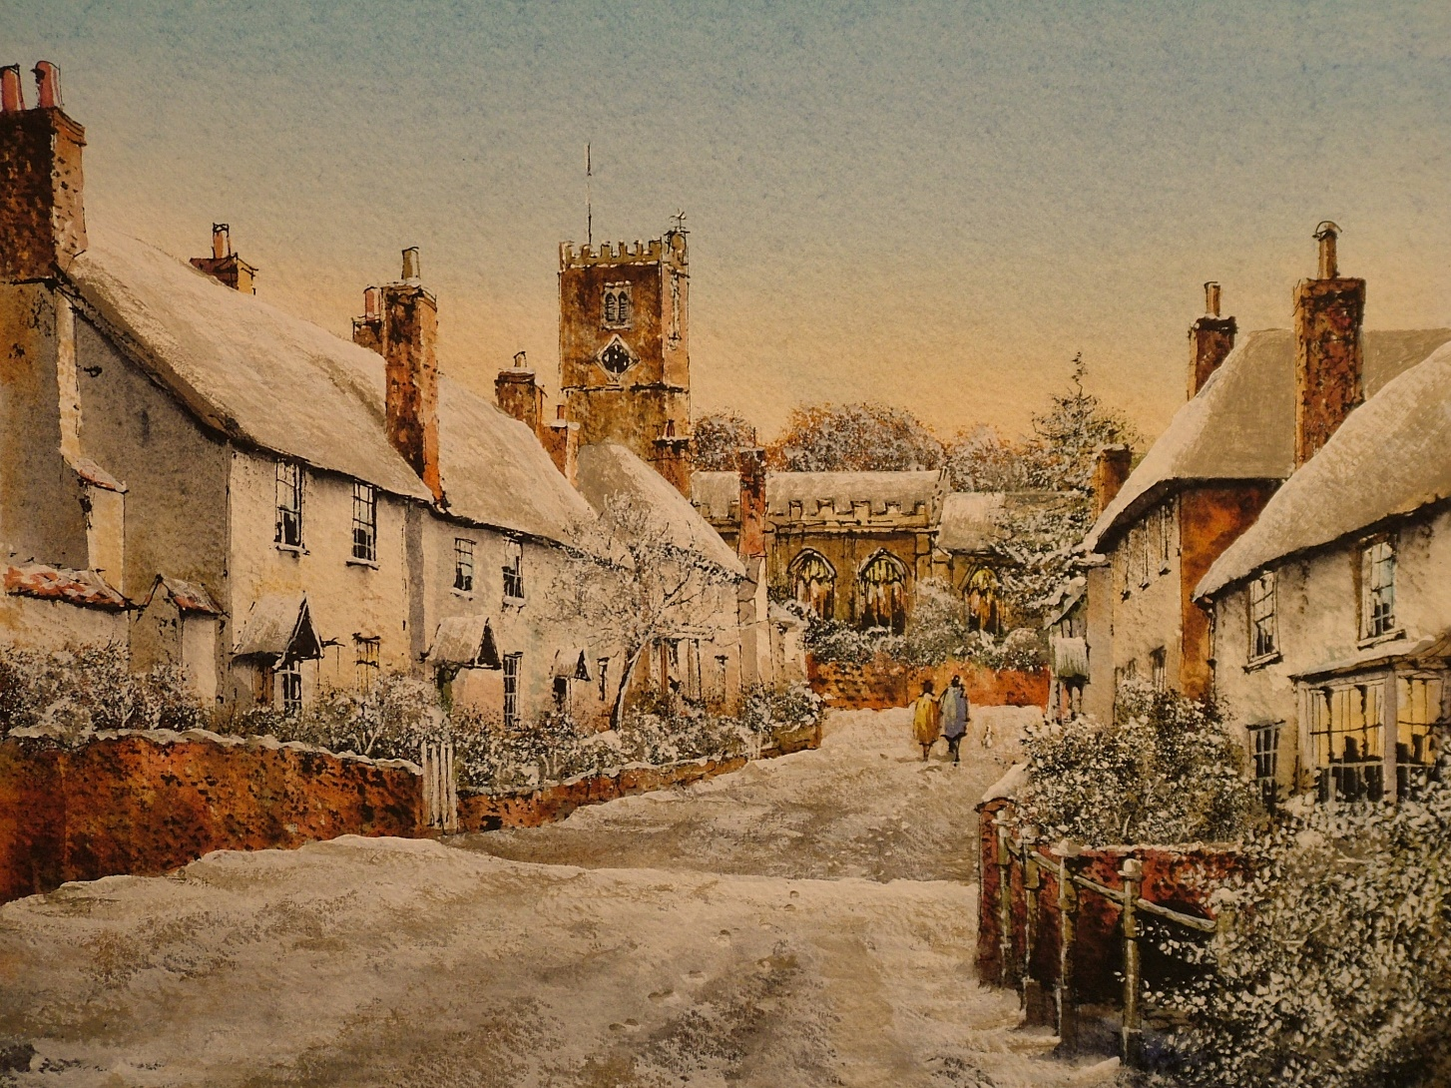

Suffolk Makers of Art and Craft.

Sat 25th Feb &
Sun 26th Feb ‘17

10am – 5pm. Free Entry.

